ADULT SUNDAY SCHOOL 9:00 AM

SUNDAY MORNING WORSHIP 10:00-11:00 AM

DOWNSTAIRS CHILDREN’S MINISTRY 10:30 AM

KCII SERMON BROADCAST 11:30 AM

WED. NIGHT BIBLE STUDY 6:30 PM

*The altar is always open for prayer/anointing before and after worship services.*

Fourth Sunday of Advent

*All visitors are encouraged to fill out the visitor cards in the pews and drop them in the offering plate at the usher’s podium. Thank you.*

**OFFICIATING** ***PASTOR RICK ZICKEFOOSE***

**WORSHIP LEADER *TERESA PETERSON***

**GREETINGS & ADVENT READING *NICOLE ZICKEFOOSE***

LIGHTING OF THE 4th ADVENT CANDLE “PEACE”

ADVENT CANDLE READING - ***Micah 5:2-5***

**MEDITATION:**  Throughout history, songs have been a profound way to express the depth of human emotion. From the psalms of David to Mary’s Magnificat, music has echoed the praises, struggles, and hopes of God’s people. Today, consider choosing a song that reflects the faith you treasure, a melody that captures the glory of your journey with Christ. Let it be a reminder of the hope and joy the season brings.

~ *Kim Kyremes-Parks*

***Please Stand for Praise and Worship Songs***

**Hymn *#170 Thou Didst Leave Thy Throne***

**Hymn *#178 O Little Town of Bethlehem***

**Hymn *#197 It Came upon the Midnight Clear***

***#440******The Lord’s Prayer***

MUSIC SPECIAL ***JOYCE DUNBAR***

CHILDREN’S BLESSING/DISMISSAL & OFFERING DEDICATION

**(The Offering Plate is placed at the Usher’s podium.)**

**PROCLAIMING THE WORD**

Therefore, when Christ came into the world, he said: “Sacrifice and offering you did not desire, but a body you prepared for me; with burnt offerings and sin offerings you were not pleased. Then I said, ‘Here I am—it is written about me in the scroll— I have come to do your will, my God.’ ” Hebrews 10:5-7

**“HEROES OF THE ADVENT”**

*Theme Verse Isaiah 6:8*

**Sermon Text** Matthew 2:18-25

**Message** *“Heroes of the Nativity – JOSEPH & MARY”*

**Closing Hymn *TBA***

**Benediction Pastor Rick**

What is Christmas

Christmas is the birth of Christ,

Mary’s little Son,

The sweetest Babe there ever was

Since time had first begun.

It marked the promise God had made

When Eden’s doors were closed…

“One day a Savior will be sent.”

The time was not disclosed.

It also is a time for love

That seems to fill the air.

People smile more easily

And try to show they care.

Those who do not know the Lord

Need only look around

To see His love at work in us…

We stand on holy ground.

*~ Margaret Peterson*

*WORSHIP LEADER ROTATION*: Pete Peterson, Anne Zickefoose, Teresa Peterson, Ken Kline-2nd Sundays

**ANNOUNCEMENTS**

* Thank you to all the Cantata singers for their amazing performance! It was sure to have touched many hearts and revealed the true meaning of Christmas. A sincere thank you to all who furnished refreshments and served!
* Invite your families and friend to join us for our Christmas Eve Candlelight Service on Tues., Dec. 24th at 7:00 pm.
* For December we are accepting Personal Supplies such as: shampoo, conditioner, body wash, deodorant, toothpaste, toothbrushes, combs and brushes for the BCC Food Pantry.
* The next Communion Service will be on Jan. 5th not Dec. 22nd.
* Parish Council meets on Mon., Jan. 6th at 6:00 pm.

We are needing mittens, hats, gloves, and scarves to adorn the Mitten Tree to make available for kids.

* The next meeting of the Washington County Right to Life will be on Jan. 27th due to family holiday celebrations from 6:30 pm-7:30 pm in person or through this link: https://meet.google.com/dqv-rsgm-egc
* The next church-wide potluck will not be held until Feb. 2nd due to the busyness of the Holiday Season and family get-togethers.

**REMEBERING IN OUR PRAYERS**

Travel mercies for all Christmas travelers.

**Nursing Home Residents**: *Halcyon House*: Jean Dunbar-Sagewood; *Fountain View Village*: Liz & Dale Gegner.

**DEC. 15th ATTENDANCE – 24 OFFERING - $605.00**

**MISSIONS - $25.00 CANTATA - $87.00**

*OPENING GREETER ROTATIONS ARE SUBJECT TO CHANGE AS NECESSARY:*

12/29-Wendy Lynn 1/5-Chuck Clifton 1/12-Cindy Bean

1/19-Wendy Lynn 1/26-Nicole Zickefoose

*Childcare/Ministry Team Rotation:*

12/22: Emerald & Destiny 12/29: Lottie & Norma

Submit announcements and prayer requests for bulletin to Cindy Bean by 4:00 pm on Thursdays. 319-653-2447 or [clbean59@iowatelecom.net](mailto:clbean59@iowatelecom.net)

Prayer will make a man cease from sin,

or sin will entice a man to cease from prayer. ~ John Bunyan



Brighton Community Church

December 22nd, 2024

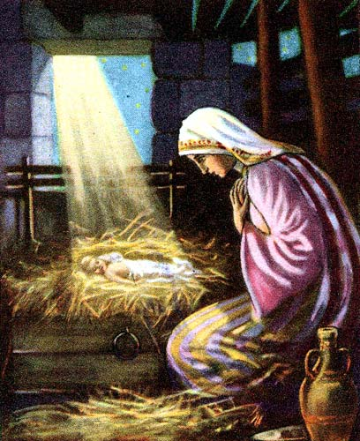

101 S. Mechanic St . Brighton, IA 52540

Church 319-694-2470

[brightoncommunitychurchia@gmail.com](mailto:brightoncommunitychurchia@gmail.com)

Church website: https://brightoncommunitychurchia.org

Pastor Rick Zickefoose 319-548-0073 rickzick3@hotmail.com