ADULT SUNDAY SCHOOL 9:00 AM

SUNDAY MORNING WORSHIP 10:00-11:00 AM

DOWNSTAIRS CHILDREN’S MINISTRY 10:30 AM

KCII SERMON BROADCAST 11:30 AM

WED. NIGHT BIBLE STUDY 6:30 PM

*The altar is always open for prayer/anointing before and after worship services.*

First Sunday of Advent

Hanging of the Greens

*All visitors are encouraged to fill out the visitor cards in the pews and drop them in the offering plate at the usher’s podium. Thank you.*

**OFFICIATING** ***PASTOR RICK ZICKEFOOSE***

**WORSHIP LEADER *PETE PETERSON***

**GREETINGS & ADVENT SCRIPTURE READING *CHUCK CLIFTON***

**Today is Communion Sunday!** We have an “open-door” policy and welcome every believer to participate in this observance at the close of today’s service. Parents are encouraged to direct their children. Please be preparing your hearts and thoughts through worship to come to the Lord’s Table with all the love and respect Jesus deserves for the Cross!

LIGHTING OF THE 1st ADVENT CANDLE “FAITH”

***Please Stand for Praise and Worship Songs***

**Hymn *Because of Bethlehem –*** *Matthew West*

**Hymn *Light of the World –*** *Lauren Daigel*

**Hymn *Somewhere in Your Silent Night –*** *Casting Crowns*

**In Unison*****The Lord’s Prayer***

**Worship Reading** **Malachi 4**

CHILDREN’S BLESSING/DISMISSAL & OFFERING DEDICATION

**(The Offering Plate is placed at the Usher’s podium.)**

**PROCLAIMING THE WORD**

Shout for joy to the Lord, all the earth. Worship the Lord with gladness; come before him with joyful songs. Know that the Lord is God. It is he who made us, and we are his; we are his people, the sheep of his pasture. Enter his gates with thanksgiving and his courts with praise; give thanks to him and praise his name. Psalm 100:1-4

“HEROES OF THE ADVENT”

*Theme Verse Hebrews 12:1-3*

**Sermon Text** Luke 1 (selected verses)

**Message** *“Zechariah, Elizabeth & John” (Part 1 of 4)*

WELCOME TO THE LORD’S TABLE

**Communion Hymn *Manger Throne –*** *Phil Wickham*

**Benediction Pastor Rick**

**See It God’s Way**

If you become God’s servant,

You must give up wordly ways.

You need to trustin Jesus,

And don’t forget to pray.

If you do things God’s way,

What blessings you’ll receive.

It only takes a moment

To trust and to believe.

*~ Donna Knapp Walrath*

***December Birthdays***

Marcella Loeffler – 12/3

Martha Lynn – 12/10

Jan Eddy – 12/11

Connie Robertson & Morgana Svestka – Dec. 18

Zane Svestka – 12/26

Joyce Dunbar & Ken Kline - !2/27

*WORSHIP LEADER ROTATION*: Pete Peterson, Anne Zickefoose, Teresa Peterson, Ken Kline-2nd Sundays

**ANNOUNCEMENTS**

* TODAY - “*Hanging of the Greens*” will take place after worship services. All are invited to participate.
* Update on the Operation Christmas Child Shoe Box Campaign: 14 boxes were filled and collected, and monetary donations of $185.00 were received, which will be mailed to Samaritan’s Purse. *Thank you to everyone who blessed a child and their family this year!*
* For December we are accepting Personal Supplies such as: shampoo, conditioner, body wash, deodorant, toothpaste, toothbrushes, combs and brushes for the BCC Food Pantry. *Thank you!*
* The next meeting of the Washington County Right to Life will be on Feb. 24th due to family holiday celebrations from 6:30 pm-7:30 pm in person or through this link: https://meet.google.com/dqv-rsgm-egc
* Only 2 weeks until The Christmas Cantata *“What Christmas Really Means”* Sun., Dec. 15th at 2:00 pm at BCC. **Please invite family, friends and neighbors!** Practice is now at 5:30 pm on Tuesday evenings. Please contact Pete Peterson with questions at 319-855-3537.
* The next church-wide potluck will not be held until February due to the busyness of the Holiday Season and family get-togethers.

**REMEBERING IN OUR PRAYERS**

Connie Robertson’s son, Ryan – continued prayers for healing from stroke; Barb’s friend, Mary – cervical cancer; Cheryl Palmer – health.

**Nursing Home Residents**: *Halcyon House*: Jean Dunbar-Sagewood; *Fountain View Village*: Liz & Dale Gegner.

**NOV. 24th ATTENDANCE – 26 OFFERING - $1,201.00**

**MISSIONS - $25.00**

*OPENING GREETER ROTATIONS ARE SUBJECT TO CHANGE AS NECESSARY:*

12/8-Wendy Lynn 12/15-Cindy Bean

12/22-Nicole Zickefoose 12/29-Wendy Lynn

*Childcare/Ministry Team Rotation:*

12/1: Terri & Emerald 12/8: Tierney & Justine 12/15: Norma & Destiny 12/22: Emerald & Destiny 12/29: Lottie & Norma

Submit announcements and prayer requests for bulletin to Cindy Bean by 4:00 pm on Thursdays. 319-653-2447 or [clbean59@iowatelecom.net](mailto:clbean59@iowatelecom.net)



Brighton Community Church

December 1st, 2024

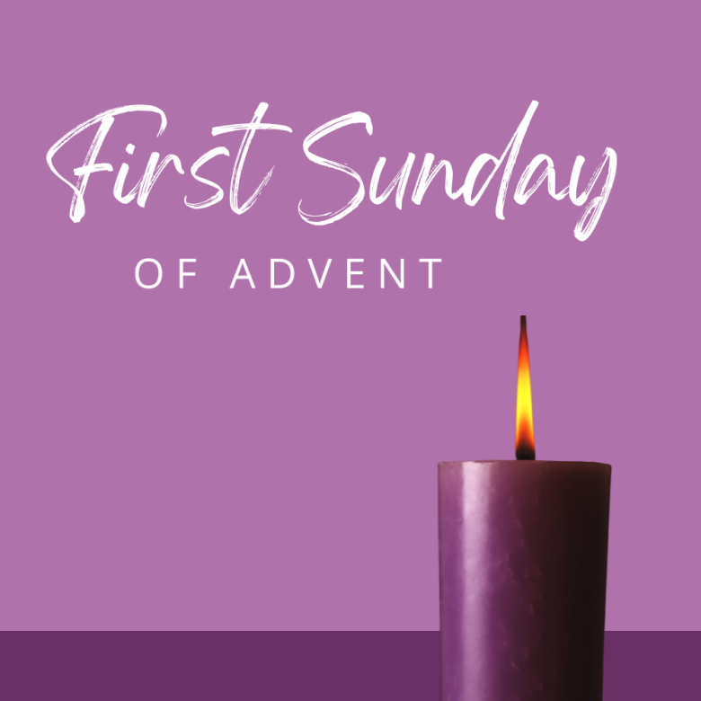

101 S. Mechanic St . Brighton, IA 52540

Church 319-694-2470

[brightoncommunitychurchia@gmail.com](mailto:brightoncommunitychurchia@gmail.com)

Church website: https://brightoncommunitychurchia.org

Pastor Rick Zickefoose 319-548-0073 rickzick3@hotmail.com